**Jesus Raises Lazarus**



**From the Dead**

**John 11:1-44**

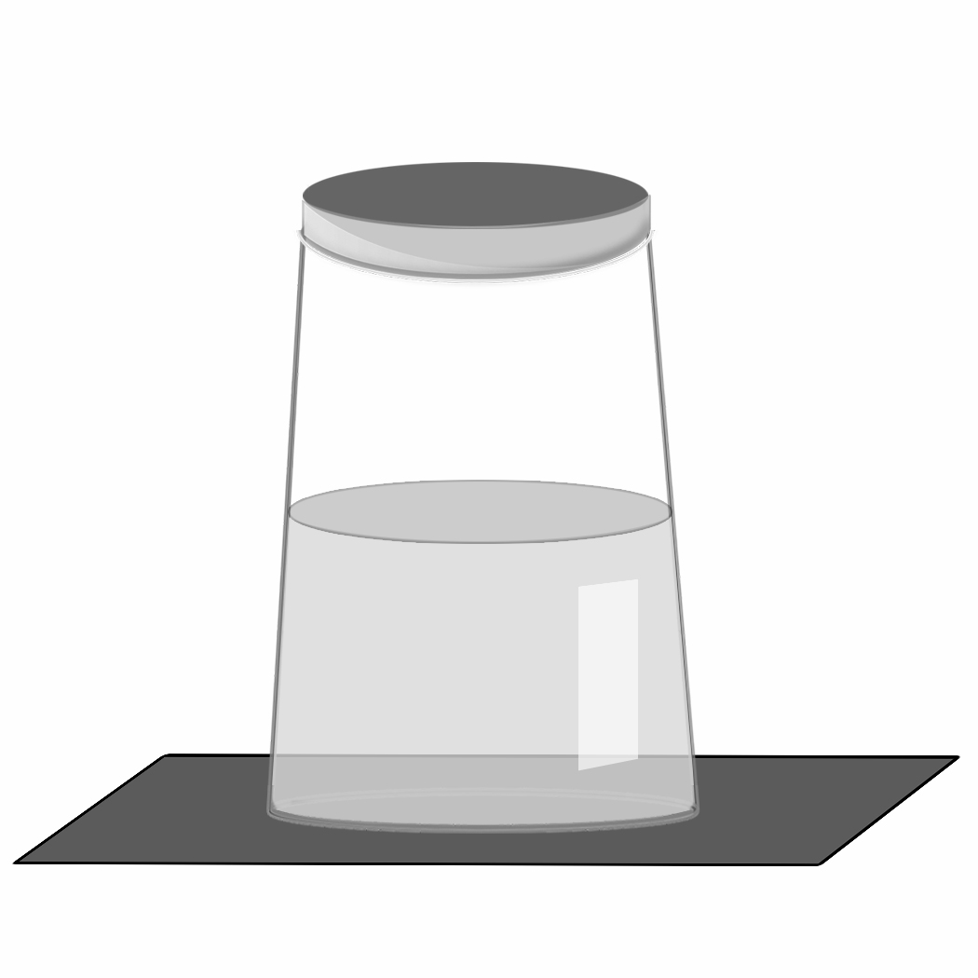

**Family Together Time**

Do a fun science experiment to see power at work!

* Fill cups about halfway with water, one for each person.
* Get pieces of cardboard that are bigger than the tops of the cups. You could cut up food boxes.
* Place the cardboard over the top of the cup. Hold it tightly against the lip of the cup as you turn the cup over. (You might want to try it over a bowl or sink first.)
* Now let go! The air pressure in the cup has so much power, it keeps the water from falling out. It’s stronger than gravity!
* Talk about how the power of the air pressure is like Jesus’ power.
* Feeling brave? Go outside or stand in the bathtub to try this experiment over each other’s heads.
* Talk about how trusting the air pressure’s power when you’re under the cup is like trusting Jesus’ power.

**Talk About This…**

* What are ways you’ve seen Jesus’ power?

Jesus learns his friend Lazarus is sick. He waits to go heal him, and Lazarus dies. Lazarus’ sisters are upset, but Jesus waited on purpose so that they could see Jesus has power over death. Jesus brings Lazarus back to life.

**Church Announcements**

* [Type your content here]

*“Jesus told her, ‘I am the resurrection and the life.  
Anyone who believes in me will live, even after dying’ ” (John 11:25).*